First and foremost…

What is git:

Git is a distributed version control system for tracking changes in source code during software development. It is designed for coordinating work among programmers, but it can be used to track changes in any set of files. Its goals include speed, data integrity, and support for distributed, non-linear workflows.

Introduction to git: <https://git-scm.com/docs/gittutorial>

May be someone can ask what is git and github?

Git vs GitHub:

<https://www.geeksforgeeks.org/difference-between-git-and-github/>

Or may be then question can raise what is gitlab? **(Optional)**

<https://www.geeksforgeeks.org/difference-between-gitlab-and-github/>

Working Directory and Staging Area or Index

The working directory is the place where files are checked out. In other CVCS, developers generally make modifications and commit their changes directly to the repository. But Git uses a different strategy. Git doesn’t track each and every modified file. Whenever you do commit an operation, Git looks for the files present in the staging area. Only those files present in the staging area are considered for commit and not all the modified files.

Let us see the basic workflow of Git.

Step 1 − You modify a file from the working directory.

Step 2 − You add these files to the staging area.

Step 3 − You perform commit operation that moves the files from the staging area. After push operation, it stores the changes permanently to the Git repository.

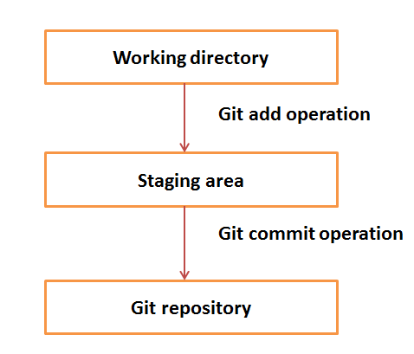

Suppose you modified two files, namely “sort.c” and “search.c” and you want two different commits for each operation. You can add one file in the staging area and do commit. After the first commit, repeat the same procedure for another file.

# First commit

[bash]$ git add sort.c

# adds file to the staging area

[bash]$ git commit –m “Added sort operation”

# Second commit

[bash]$ git add search.c

# adds file to the staging area

[bash]$ git commit –m “Added search operation”

You can also add and commit in one line: git commit -a -m “Commit message”

Reference link for above details:

<https://www.tutorialspoint.com/git/git_basic_concepts.htm>

There are many git commands, the most common git commands are:

<https://www.freecodecamp.org/news/10-important-git-commands-that-every-developer-should-know/>

Async programming:

<https://codedamn.com/news/reactjs/handle-async-functions-with-ease>

React ES6:

<https://www.w3schools.com/react/react_es6.asp>

**What is ES6?**

ES6 stands for ECMAScript 6.

ECMAScript was created to standardize JavaScript, and ES6 is the 6th version of ECMAScript, it was published in 2015, and is also known as ECMAScript 2015.

Here are the ES6 features we'll cover in this guide:

* Modules
* Destructuring
* Spread Operator
* Arrow functions
* Template Literals

I’m not sure about the syntax but you can check from below link and extract the important details:

<https://www.freecodecamp.org/news/how-to-use-es6-javascript-features-in-react/>